**USACE Portland District (NWP) FFDRWG Update Form**  
**13 August 2014**

**PROJECT INFORMATION**

|  |  |
| --- | --- |
| Project Title | B2 AWS Fish Unit Trash Rake Improvements |
| SCT Reference Number |  |
| Project Manager (PM) | Eric Stricklin (NWP, 503-808-4757) |
| Technical Lead (TL) | Ben Filan (NWP, 503-808-4925) |
| Biologist/Coordination | Jon Rerecich (NWP, 503-808-4779) |

**PROJECT DESCRIPTION**

The U.S. Army Corps of Engineers (Corps), Regional fisheries agencies, and

tribes have been concerned with deficiencies in the Auxiliary Water Supply (AWS) system

for the adult fishway at the Bonneville Second Powerhouse (B2). The basis for concern has

largely been due to improved fish passage data as well as events since 2001 when debris

accumulation occurred in and upstream of the AWS that significantly impaired the operation

and performance of the AWS system.

Current operations during periods of elevated debris in the Columbia River have required

that the Fish Units that supply water to the AWS system be shut down for short durations.

This procedure enables project personnel to float the debris away from the Fish Units in

order to maintain a safe range of head loss across the trash racks. There is evidence that

shutting the units down is detrimental to salmonid and lamprey passage due to the

inability to maintain fish ladder operating criteria.

DDR recommendations for design changes and actions:

*Construction:*

1. Existing rake should be modified to improve its ability to strip and retain matted grasses from the surface of the intake racks.

*Operations and Maintenance:*

1. Rake as needed to maintain acceptable rack differentials.
2. Maintain design bathymetry in front of the Fish Units by maintenance dredging the forebay. Develop criteria to initiate action to dredge based on results of annual monitoring of sediment accumulation.
3. Rake as needed based on rate of debris accumulation and known high debris periods.
4. Conduct annual sediment buildup monitoring upstream of the fish units following peak

spring river flows based on bathymetry and soundings so that a dredging contract can be executed for the next in water work period.

1. Monitor water height differential at each trash rack before and after cleanings and

floating of debris. These events should be logged with date, time, duration, and any other information deemed necessary by the operator.

1. Annually remove intake racks and manually remove wedged in woody debris.
2. Biennial rack inspection of the structure, coating system, and damage repair.
3. Periodically exercise Auxiliary Water Supply (AWS) system diffuser gates that are not

used regularly.

1. Continue to operate with the existing trash racks and maintain intake rack bar to bar

spacing of 0.875 inch until new evidence requires a change.

1. Float debris only in emergency situations.

**CURRENT SCHEDULE**

Bonneville Project rake modifications are underway. The rake will be modified in phases (as opposed to completely stripped and rebuilt) so it can be returned to PH2 for use partially modified when late summer grass accumulation begins.

ROV inspection targeted for November following the fall fish run and prior to winter maintenance period when Fish Units will be out of service.

**PROGRESS AND KEY ISSUES (List)**

Contracting the Perforated plates took longer than anticipated and project resourcing constraints resulted in a delay to modifications to meet the Aug. 6th ROV inspection. ROV inspection will need to be coordinated for a later date.

8/12/14 update from Bon project –

A photo of what the project has done to date. They have the brush mounting plates installed (one brush installed). Their next effort is getting all the existing tines lined up/straight so that they can install the new cap plate (scraper). Then Bon needs the perforated plate. Contracting only has one bid from a contractor. They need two. Late last week, contracting went out to three other companies for bids. Contracting said that they should get one more bid from one of the three and that the bids are due tomorrow.

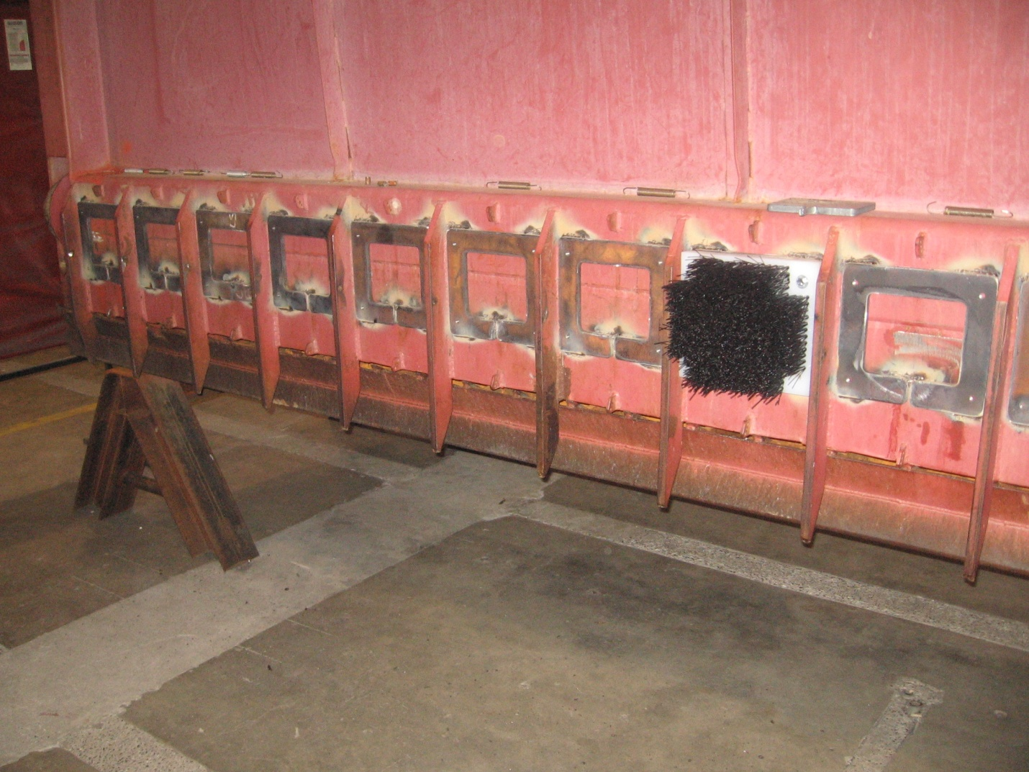

**FFDRWG REVIEW NEEDED AT MEETING? (If YES, list discussion topics below)**

No review is required at this time. FFDRWG and FPOM will be updated as progress and operations coordination is needed.